**이미지 분류 과제**

**허재호**

**Train Output**

Epoch [1/20], Train Loss : 3.0886, Train Acc : 0.4369, Val Loss : 1.6460, Val Acc : 0.7928

Epoch [2/20], Train Loss : 0.8262, Train Acc : 0.9568, Val Loss : 0.3360, Val Acc : 0.9730

Epoch [3/20], Train Loss : 0.1652, Train Acc : 0.9914, Val Loss : 0.1009, Val Acc : 0.9970

Epoch [4/20], Train Loss : 0.0463, Train Acc : 0.9985, Val Loss : 0.0459, Val Acc : 0.9955

Epoch [5/20], Train Loss : 0.0230, Train Acc : 0.9981, Val Loss : 0.0514, Val Acc : 0.9925

Epoch [6/20], Train Loss : 0.0193, Train Acc : 0.9974, Val Loss : 0.1041, Val Acc : 0.9820

Epoch [7/20], Train Loss : 0.0181, Train Acc : 0.9977, Val Loss : 0.0556, Val Acc : 0.9895

Epoch [8/20], Train Loss : 0.0117, Train Acc : 0.9985, Val Loss : 0.0488, Val Acc : 0.9895

Epoch [9/20], Train Loss : 0.0143, Train Acc : 0.9974, Val Loss : 0.1156, Val Acc : 0.9835

Epoch [10/20], Train Loss : 0.0095, Train Acc : 0.9992, Val Loss : 0.0892, Val Acc : 0.9865

Epoch [11/20], Train Loss : 0.0121, Train Acc : 0.9981, Val Loss : 0.1213, Val Acc : 0.9745

Epoch [12/20], Train Loss : 0.0076, Train Acc : 0.9989, Val Loss : 0.0861, Val Acc : 0.9865

Epoch [13/20], Train Loss : 0.0171, Train Acc : 0.9962, Val Loss : 0.1149, Val Acc : 0.9790

Epoch [14/20], Train Loss : 0.0157, Train Acc : 0.9974, Val Loss : 0.0985, Val Acc : 0.9775

Epoch [15/20], Train Loss : 0.0151, Train Acc : 0.9966, Val Loss : 0.1005, Val Acc : 0.9760

Epoch [16/20], Train Loss : 0.0238, Train Acc : 0.9962, Val Loss : 0.1235, Val Acc : 0.9760

Epoch [17/20], Train Loss : 0.0114, Train Acc : 0.9970, Val Loss : 0.1026, Val Acc : 0.9745

Epoch [18/20], Train Loss : 0.0172, Train Acc : 0.9962, Val Loss : 0.0948, Val Acc : 0.9850

Epoch [19/20], Train Loss : 0.0130, Train Acc : 0.9959, Val Loss : 0.0988, Val Acc : 0.9805

Epoch [20/20], Train Loss : 0.0141, Train Acc : 0.9970, Val Loss : 0.1034, Val Acc : 0.9805

**Train, Validation Accuracy and Loss**

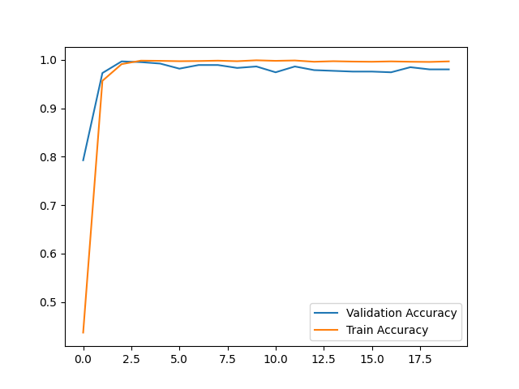

**Test Output**

Test Set : Acc [664/666] 100%

**Test Output Images**

